19-8-2020 Sebin Wilson E

Roll No. 26

EXPERIMENT No.1

Computation of Inductance of Single Phase and Three phase Transmission Line

Aim

To compute the inductance of single phase and three phase transmission line.

Software Platform

Scilab

Theory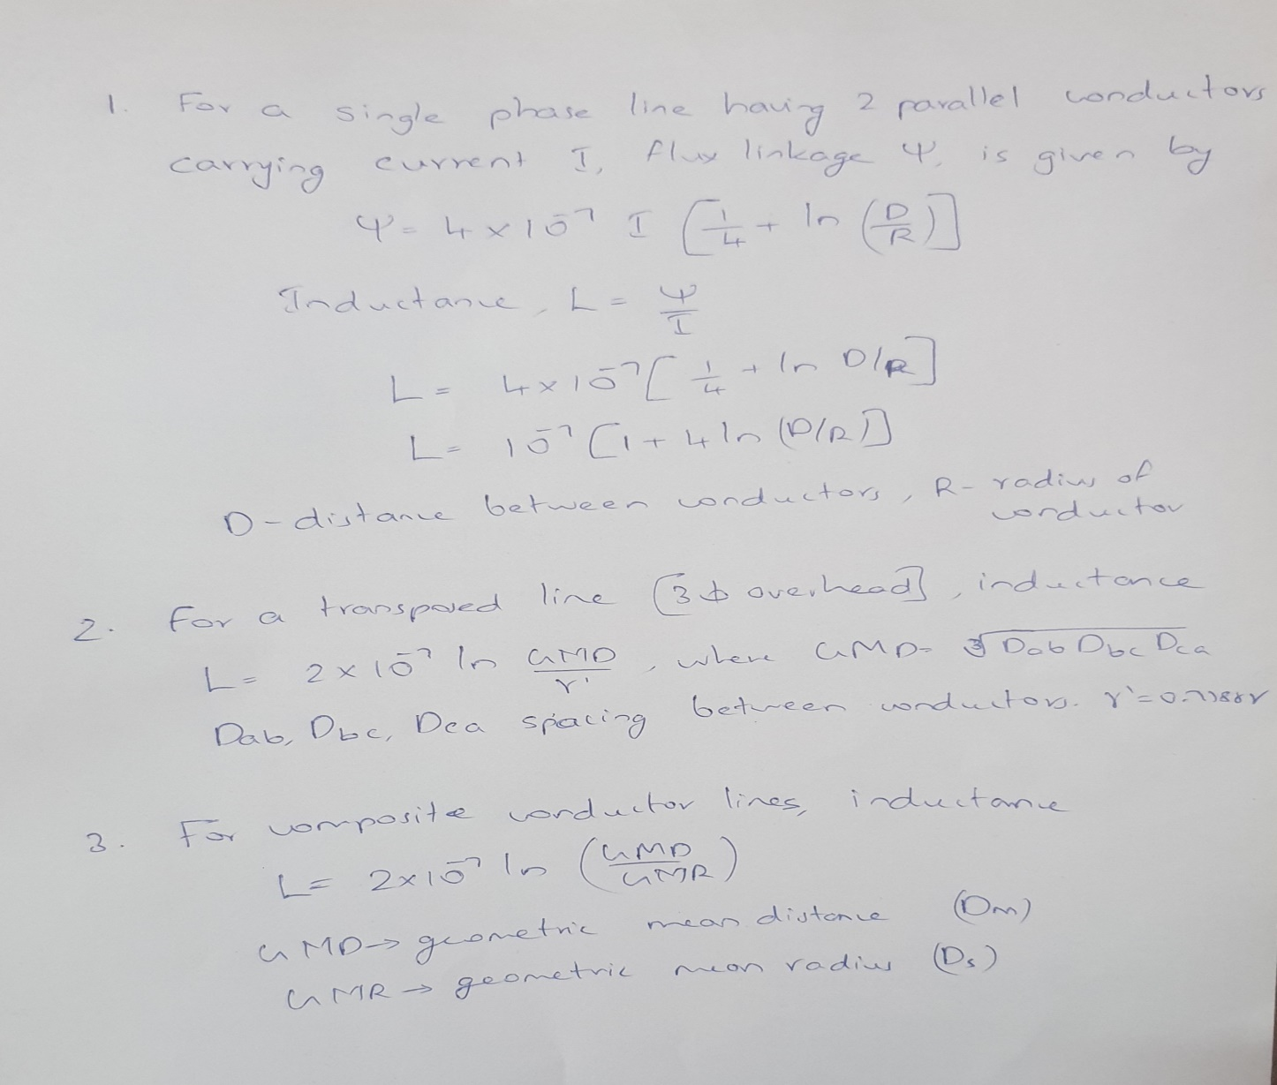

Program

Q1. Single phase line has two parallel conductors 2 metres apart. The diameter of each conductor is 1·2 cm. Calculate the loop inductance per km of the line.

Sol.

Spacing of conductors, *d* = 2 m = 200 cm

Radius of conductor, *r* = 1·2/2 = 0·6 cm

Loop inductance per metre length of the line

= 10-7 (1 + 4 log*e d*/*r*) H

= 10-7 (1 + 4 log*e* 200/0·6) H

= 24·23  10-7 H

Loop inductance per km of the line

=24·23  10−7  1000 = 24·23  10−4 H = 2·423 mH

Sample Program

1. *//Program to find the inductance of a single phase transmission line//*
2. *// Scilab Version 6.1.0; OS: Windows*
3. clc ;
4. clear ;
5. d=input("Enter the spacing between conductors in metres: ")
6. dia=input("Enter the diameter of the conductors in metres:")
7. r= dia/2
8. li =10^(-7)\*(1+4\*(log(d/r)))\*1000
9. disp("The Inductance per kilometre of given transmission line in H is: ",li)

Sample Output

Enter the spacing between conductors in metres: 2

Enter the diameter of the conductors in metres: 1.2e-3

"The Inductance per kilometre of given transmission line in H is: "

0.0024237

Q2. Calculate the inductance of each conductor in a 3-phase, 3-wire system when the conductors are arranged in a horizontal plane with spacing such that D31 = 4 m ; D12 = D23 = 2m. The conductors are transposed and have a diameter of 2·5 cm.

Sol: 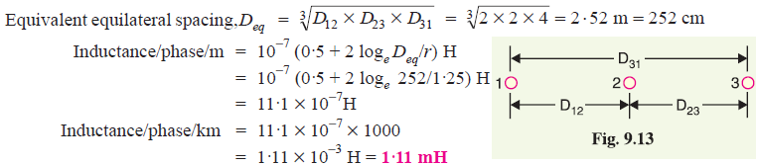

Sample Program

1. *//Program to find the inductance of a Three phase transmission line//*
2. *// Scilab Version 6.1.0; OS :Windows*
3. clc ;
4. clear ;
5. d12=input("Enter the spacing between conductors 1 and 2 in metres: ")
6. d23=input("Enter the spacing between conductors 2 and 3 in metres: ")
7. d31=input("Enter the spacing between conductors 3 and 1 in metres: ")
8. deq =(d12\*d23\*d31)^(1/3)
9. dia=input("Enter the diameter of the conductors in meter:")
10. r= dia/2
11. li =10^(-7)\*(0.5+2\*(log(deq/r)))\*1000
12. disp("The Inductance per kilometre of given transmission line in H is: ",li)

Sample Output

Enter the spacing between conductors 1 and 2 in metres: 2

Enter the spacing between conductors 2 and 3 in metres: 2

Enter the spacing between conductors 3 and 1 in metres: 4

Enter the diameter of the conductors in meter: 2.5e-2

"The Inductance per kilometre of given transmission line in H is: " 0.0011112

Q3. Calculate the inductance per phase per metre for a three-phase double-circuit line whose phase conductors have a radius of 5·3 cm with the horizontal conductor arrangement as shown in Fig. 9.17

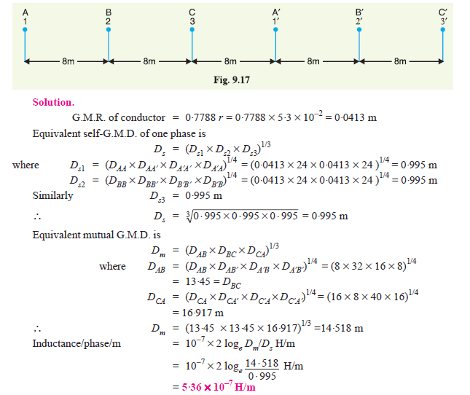

Sample Program

1. *//Program to find the inductance per phase per metre for a 3 phase double circuit line*
2. clc;
3. clear;
4. format('v',20)
5. r=input("Enter the radius of the conductors in cm: ")
6. GMR=0.7788\*r\*10^-2
7. dab=input("Enter the spacing of A and B in ms: ")
8. dbc=input("Enter the spacing of B and C in ms: ")
9. dca1=input("Enter the spacing of C and A'' in ms: ")
10. da1b1=input("Enter the spacing of A'' and B'' in ms: ")
11. db1c1=input("Enter the spacing of B'' and C'' in ms: ")
12. daa1=dab+dbc+dca1
13. dbb1=dbc+dca1+da1b1
14. dcc1=dca1+da1b1+db1c1
15. Ds1=(GMR^2\*daa1^2)^(1/4)
16. Ds2=(GMR^2\*dbb1^2)^(1/4)
17. Ds3=(GMR^2\*dcc1^2)^(1/4)
18. Ds=(Ds1\*Ds2\*Ds3)^(1/3)
19. dab1=daa1+da1b1
20. dba1=dbc+dca1
21. dac=dab+dbc
22. dac1=dab1+db1c1
23. dc1a1=da1b1+db1c1
24. dbc1=dbb1+db1c1
25. dcb1=dcc1-db1c1
26. Dab=(dab\*dab1\*dba1\*da1b1)^(1/4)
27. Dca=(dac\*dca1\*dac1\*dc1a1)^(1/4)
28. Dbc=(dbc\*dbc1\*dcb1\*db1c1)^(1/4)
29. Dm=(Dab\*Dbc\*Dca)^(1/3)
30. L=10^(-7)\*2\*(log(Dm/Ds))
31. disp("The inductance per phase per metre of given transmission line in H/m is:",L)

Sample Output

Enter the radius of the conductors in cm: 5.3

Enter the spacing of A and B in ms: 8

Enter the spacing of B and C in ms: 8

Enter the spacing of C and A' in ms: 8

Enter the spacing of A' and B' in ms: 8

Enter the spacing of B' and C' in ms: 8

"The inductance per phase per metre of given transmission line in H/m is:" 0.00000053607295167

Q4. 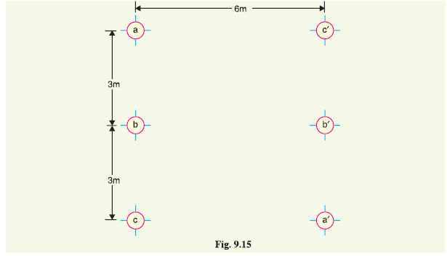 Fig. 9.15 shows the spacing of a double circuit 3-phase overhead line. The phase sequence is ABC and the line is completely transposed.The conductor radius in 1·3 cm. Find the inductance per phase per kilometre.

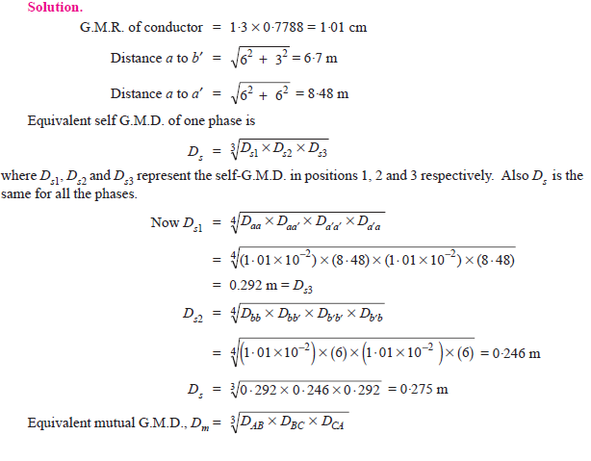

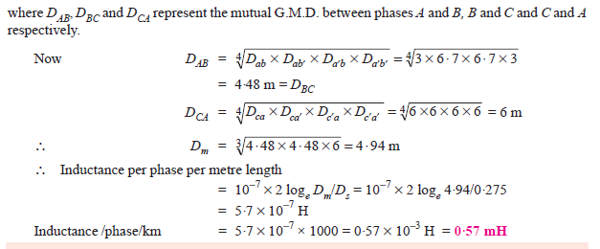

Sample Program

1. *//Program to find the inductance per phase per metre for a 3 phase double circuit line*
2. clc;
3. clear;
4. format('v',20)
5. r=input("Enter the radius of the conductors in cm: ")
6. GMR=0.7788\*r\*10^-2
7. dab=input("Enter the spacing of A and B in ms: ")
8. dbc=input("Enter the spacing of B and C in ms: ")
9. dac1=input("Enter the spacing of A and C'' in ms: ")
10. dbb1=input("Enter the spacing of B and B'' in ms: ")
11. dca1=input("Enter the spacing of C and A'' in ms: ")
12. da1b1=input("Enter the spacing of A'' and B'' in ms: ")
13. db1c1=input("Enter the spacing of B'' and C'' in ms: ")
14. daa1=(dac1^2+(dab+dbc)^2)^1/2
15. dab1=(dab^2+dac1^2)^1/2
16. dcc1=daa1
17. dba1=dab1
18. dbc1=dab1
19. dcb1=dab1
20. dac=dab+dbc
21. dc1a1=dac
22. Ds1=(GMR^2\*daa1^2)^(1/4)
23. Ds2=(GMR^2\*dbb1^2)^(1/4)
24. Ds3=(GMR^2\*dcc1^2)^(1/4)
25. Ds=(Ds1\*Ds2\*Ds3)^(1/3)
26. Dab=(dab\*dab1\*dba1\*da1b1)^(1/4)
27. Dca=(dac\*dca1\*dac1\*dc1a1)^(1/4)
28. Dbc=(dbc\*dbc1\*dcb1\*db1c1)^(1/4)
29. Dm=(Dab\*Dbc\*Dca)^(1/3)
30. L=10^(-7)\*2\*(log(Dm/Ds))\*1000
31. disp("The inductance per phase per metre of given transmission line in H/Km is:",L)

Sample Output

Enter the radius of the conductors in cm: 1.3

Enter the spacing of A and B in ms: 3

Enter the spacing of B and C in ms: 3

Enter the spacing of A and C' in ms: 6

Enter the spacing of B and B' in ms: 6

Enter the spacing of C and A' in ms: 6

Enter the spacing of A' and B' in ms: 3

Enter the spacing of B' and C' in ms: 3

"The inductance per phase per metre of given transmission line in H/Km is:" 0.00056091325230290

Result

The inductance of the given single phase and three phase transmission lines were calculated through Scilab and the results were compared with manual calculations.